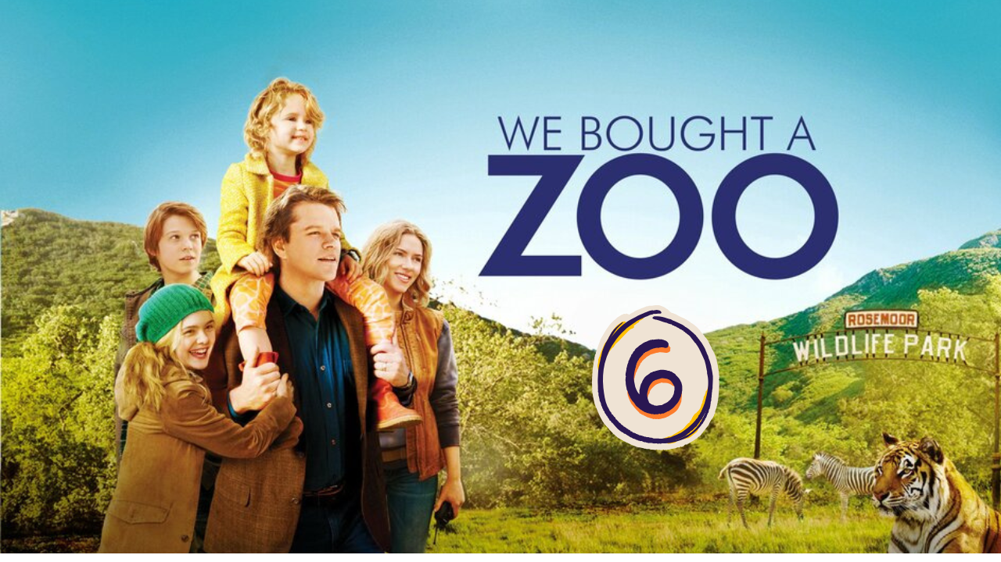
“We Bought a ZOO” (Scene 06)

Part 01 / Work on the Scene

- Scene events summary:

“Mr. Benjamin starts a new journey, taking a tour around the zoo to count the missing things the animals need. Kelly asks him why he bought the zoo when he doesn’t know anything about wild animal life or how to keep them safe and alive in an enclosure. He surprises her by simply saying, “Why not?” At the end of the scene, Benjamin’s brother asks him to change his mind and quit the zoo, but he doesn’t succeed.

- Scene Discussion & Analysis:

- Q01: What was wrong with Spar?
He was old.
- Q02: Did it cost too much to take care of him?
I don’t know.
- Q03: Why did Kelly seem hesitant to make that investment?
She didn’t trust Mr Benjamin.
- Q04: How are the animal cages in the ZOO officially called?
They are called enclosure.
- Q05: Based on your personal analysis, why are they no longer called “cages”?
In my opinion, they are no longer called cages, since the word “cages” suggests imprisonment.
- Q06: Was Benjamin’s name known in the ZOO community?
No, it wasn’t.
- Q07: Did he have a good reason to buy the ZOO, though?
No, he didn’t have a good reason to bay the zoo.
- Q08: If not, what do you think made him take that risky decision in your opinion? (How would you analyze his decision?)
He bought the zoo to make his daughter Rosie happy.
- Q09: Did Kelly feel secure with Benjamin taking charge of the ZOO? Can you explain why (based on your understanding)??
Kelly didn’t feel confident with Benjamin taking charge of the zoo since he had no experience in this field.

Part 02 / Acquired vocabulary & Grammar from the scene

- Acquired Vocabulary (OPTIONAL):

- To get along:
- Example in a sentence:
“ We get along very well with our neighbours.”
- To drill yourself into something:
- Example in a sentence:
“ She drilled herself on the multiplication tables every day before the math competition.”
- Pathetic (adj):
- Example in a sentence:
“ ..... .... .... .... .... .... .... .... .... .... .... .... .... .... .... .... .... .... .... .... .... .... .... .... ... .... .... .... .... .... .... .... .... ... .... .”
- Docile (adj):
- Example in a sentence:
The hungry stray kitten let out a pathetic little cry.
He made a pathetic attempt to apologize, but no one believed him.

- Irregular Verbs:

Infinitive | Past simple | Past participle
To meet | met | met
To take charge | To took charge | To token charge
To make | made | made

Part 03 / TRANSCRIPTION: improve your listening (Optional)

Task: Transcribe sentences from the scene.
- Transcribe Sentence 01
- Spar who we just meet, the tiger is gone need some special cares, so we have a large animals that coming from Santiago it is just its unfortunate to get here and
- Transcribe Sentence 02
- I am pathetic, I have to move back with my mother. No one get payed Benjamin we need someone can really take charge of this place Rose we and all this animals gone

Open discussion (OQ)
\
- Topic of discussion: Kelly Foster was trying to make a point clear that Benjamin Mee was playing havoc with the ZOO and staff. She doubted his ability to succeed in a business he barely knew about. In your opinion, do you think it is wise to invest in a business with the minimum knowledge? How risky is it? And if you were in Benjamin’s play with good capital, what business would you invest in? (every participant gives 1 or 2 business ideas to be discussed)
(Students are free to participate and interact to share their own opinions.)
(Students are encouraged to prepare their arguments before the session.)

In my opinion, it is not wise to invest in a business we don’t know well, because the consequences of such actions can be disastrous and irreversible. I think it would be wise to move slowly and create a plan and strategy that cover all possibilities, even in case the project fails before it starts. In addition, good knowledge is essential for success.
Taking this risky path can lead to losing our capital, and moreover, to becoming indebted. Besides all this, the impact of failure is very intense on our morale.
I am not a business expert, but if I were him, I would follow the steps I mentioned before. First, I would try a less risky business, and more importantly, I would never invest all my funds in the same project.

